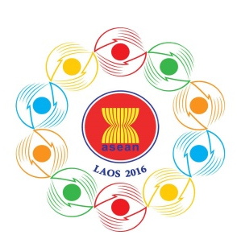

Turning Vision into Reality

for a Dynamic ASEAN Community
Laos 2016
‘Promoting Defence Cooperation for a Dynamic ASEAN Community’

10th ASEAN DEFENCE MINISTERS’ MEETING (10th ADMM)
Vientiane, Lao PDR, 24-27 May 2016
Tentative Programme of Activities
Tuesday, 24 May 2016
AM/PM - Arrival of Delegations
AM/PM - Bilateral Meetings
Venue : TBC
1700 - 1800 - Staff Meetings
Attendees : Working Group Officials
Venue : TBC
Attire : Smart Casual

Wednesday, 25 May2016
0900 – 1200 - 10th ADMM
Attendees : All Delegates
Venue : National Convention Centre
Attire : Lounge Suit / Military Uniform

0900 - 0910 - Group Photo of Heads of Delegations
0915 - 1030 - 10th ADMM
1030 - 1045 - Coffee Break
1045 - 1200 - 10th ADMM
1200 - 1330 - Luncheon
1330 - 1400 - Signing of Joint Declaration of the 10th ADMM on “Promoting Defence Cooperation for a Dynamic ASEAN Community”
Venue : National Convention Centre

1400 - 1430 - Press Conference
Venue : National Convention Centre
1430 - 1600 - [ ASEAN-China Defence Ministers’ Informal Meeting ]
Attendees : Heads of Delegations (+ 3 Officials
+ Interpreter)
Venue : National Convention Centre
Attire : Lounge Suit / Military Uniform
1600 - 1615 - Coffee Break
1615 -1700 - Courtesy Call on Prime Minister of Lao PDR
Attendees : Heads of Delegations + 1 interpreter
1700 - 1900 - Bilateral Meetings / Free Time
1900 - 2100 - ADMM Gala Dinner hosted by Minister of National Defence, Lao PDR and Spouse
Attendees : All delegates
Venue : TBC
Attire : Lao Traditional Shirt for HODs
Smart Casual / National Dress for other delegates

Thursday, 26 May 2016
0900 - 1200 - Commemoration of the 10th Anniversary of ADMM
- Tree plantation by Heads of Delegations
- Opening Ceremony of ADMM Photo Gallery
1200 – 1330 - Luncheon
Venue : Landmark Mekong Riverside Hotel
1400 – 1700 - Cultural Visit
PM - Free Programme
Friday, 27 May 2016
AM/PM - Departure of Delegations

