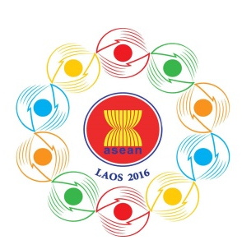
Turning Vision into Reality

for a Dynamic ASEAN Community
Laos 2016
‘Promoting Defence Cooperation for a Dynamic ASEAN Community’

10th ASEAN DEFENCE MINISTERS’MEETING (10th ADMM)
Vientiane, Lao PDR, 24-27 May 2016

Tentative Programme of Activities for Spouses

Tuesday, 24 May 2016
AM / PM Arrival of Delegations
Wednesday, 25 May 2016
0800-0900 Breakfast (all spouses)
0930-1130 Visit:
- Victory Gate (Patu Xay)
- That Luang Stupa
- Song Meu Nang Handicraft
- Attire: Smart Casual
1200-1330 Lunch at Landmark Mekong Riverside Hotel
1400-1630 Visit:
- Silk Textile Factory
- Talat Sao Mall
- Attire: Smart Casual
1900-2100 ADMM Gala Dinner hosted by Ministry of National
Defence, Lao PDR and Spouse
- Attendees: All delegates
- Venue: TBC
- Attire: Lao traditional shirt for HODs
Smart Casual / National Dress for
other delegates

Thursday, 26 May 2016

0900-1200 Visit:
- Friendship Bridge
- Duty Free Shop
- Khampengvieng Shop
- Attire: Smart Casual

1200-1330 Lunch at Landmark Mekong Riverside Hotel
1400-1630 Visit:
        - ITECC
        - Vientiane Centre
- Attire: Smart Casual
Friday, 27 May 2016
AM / PM Departure of Delegations

