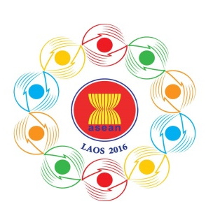
Turning Vision into Reality

for a Dynamic ASEAN Community
Laos 2016
‘Promoting Defence Cooperation for a Dynamic ASEAN Community’

ADSOM-Plus
Vientiane, Lao PDR, 23-25 April 2016
SHIRT MEASUREMENT FORM
Please complete the shirt measurement below for administrative arrangement and kindly submit it to the 10th ADMM Secretariat by 15 March 2016.

A Collar
C E
G Chest

D H Waist
J I
Wrist B Hip

- Country: __________________________________________________________
- Name of HOD: _____________________________________________________
- A --- B: Full Length of Shirt: _________________ cm
- C --- E: Full Length of Shoulders: __________________cm
- C --- D: Full Length of Sleeves: __________________cm
- F: Full Round of Collar: __________________cm
- G: Chest Width: __________________cm
- H: Waist Width: __________________cm
- I: Hip Width: __________________cm
- J: Wrist Width: __________________cm

