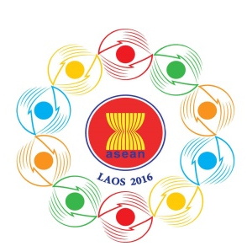

Turning Vision into Reality
for a Dynamic ASEAN Community
Laos 2016
“Promoting Defence Cooperation for a Dynamic ASEAN Community”

ASEAN DEFENCE MINISTERS’ MEETING RETREAT
Vientiane, Lao PDR, 15-17 November 2016
15-17 November 2016

Registration Form

Photo
4x6 cm

- COUNTRY:

- CATEGORY OF GUEST: (Please tick)

 | Delegation member
 | Supporting Staff
 | Driver | Car plate number:

- GUEST INFORMATION
Title / Rank:

Guest Name:

Name on tag:

Designation:

Ministry / Organisation /
Department:

Telephone / Fax:

Email:

- DIETARY REQUIREMENTS

Please detail any dietary requirements you may have:

………………………………………………………………………………………………
………………………………………………………………………………………………..

Kindly submit the registration form by 24 October 2016,
either by fax or e-mail to the following contact:

10th ADMM Secretariat
Tel: + 856 21 911727
Fax: + 856 21 911728
Email: admm2016laos@yahoo.com

