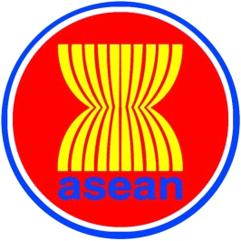

9th ADMM-Plus Experts’ Working Group on
Humanitarian Assistance and Disaster Relief Meeting
14-16 December 2016, Vientiane, Lao PDR

_______________________________________________

Registration Form

Photo
4x6 cm

- Delegate’s Details
Country:
Head of Delegation (please tick) |  |  |  | Delegate (please tick)
Rank/Title:
Full Name:
Name on tag:
Passport No.:
Position:
Organisation:
Address:
Tel.: |  |  |  | Fax:
E-Mail:
2. Flight Details
Information |  |  | Arrival |  |  | Departure
Date
Time
Flight No.

3. Accommodation during the meeting

……………………………………………………………………………………………………………………
……………………………………………………………………………………………………………………

4. Dietary Requirements

Please detail any dietary requirements you may have:
……………………………………………………………………………………………………………………
……………………………………………………………………………………………………………………

Kindly submit the completed registration form by 28 November 2016,
by fax or e-mail to the following contact:

Fax: +856 21 911728
lae.army@gmail.com and t_thouan@hotmail.com

