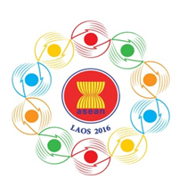
Turning Vision into Reality

for a Dynamic ASEAN Community
Laos 2016
“Promoting Defence Cooperation for a Dynamic ASEAN Community”

ASEAN DEFENCE MINISTERS’ MEETING RETREAT
And ASEAN-JAPAN DEFENCE MINISTERS’ INFORMAL MEETING
Vientiane, Lao PDR, 15-17 November 2016

Clothing Measurement for HODs

Country: ………………...............

Measurements:

- Neck : cm

- Shoulders : cm

- Chest : cm

- Waist : cm

- Hips : cm

- Shirt Length : cm

- Sleeve Length : cm

- Biceps : cm

- Wrist / Cuff : cm

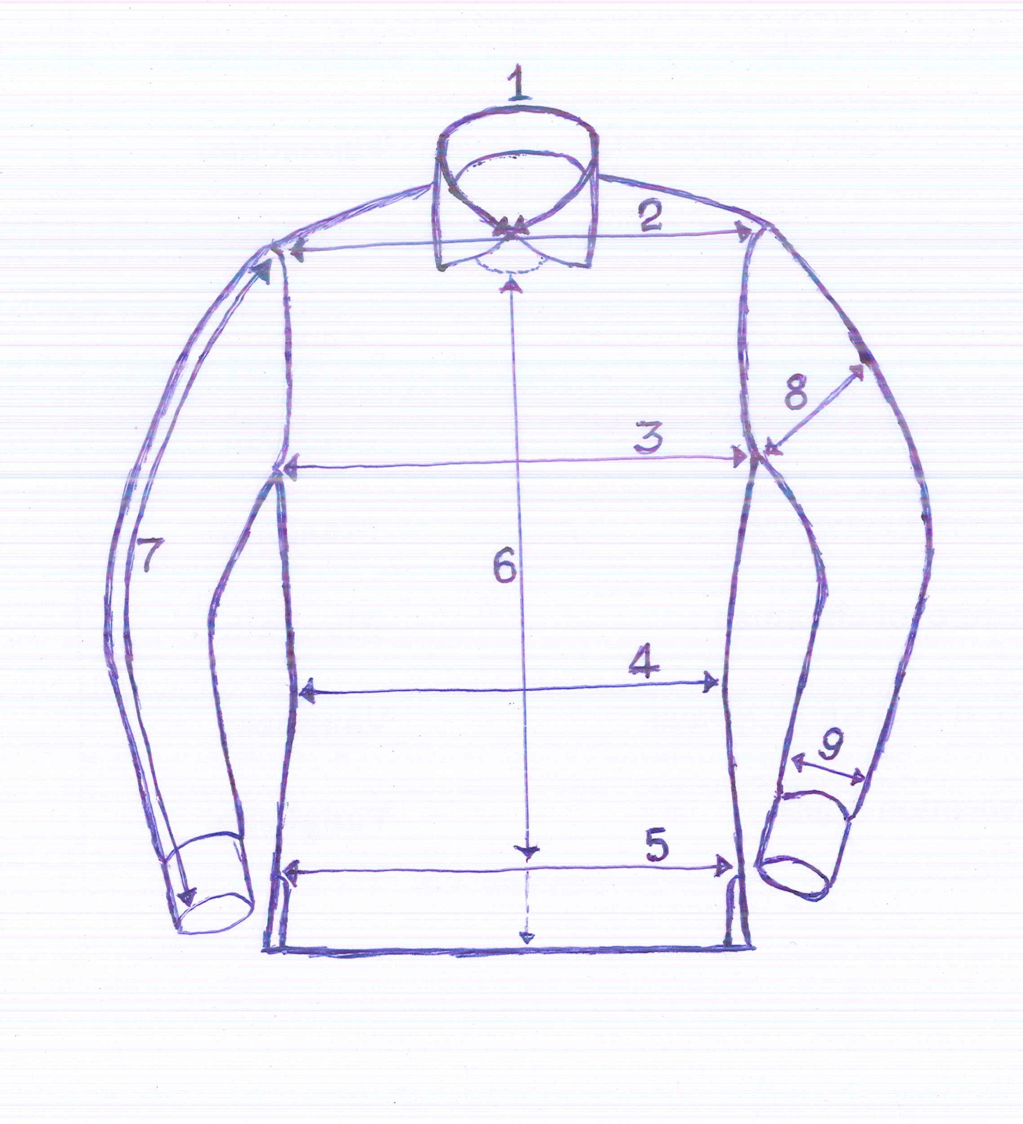

Please kindly return the completed form to the 10th ADMM Secretariat by 09 October 2016 at email: admm2016laos@yahoo.com

