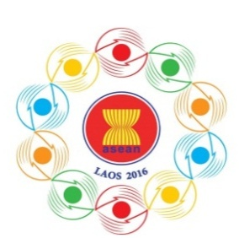

Turning Vision into Reality

for a Dynamic ASEAN Community
Laos 2016
‘Promoting Defence Cooperation for a Dynamic ASEAN Community’

10th ASEAN DEFENCE MINISTERS’ MEETING (10th ADMM)
Vientiane, Lao PDR,24-27 May 2016

Bilateral Meeting Form
Country: Lao PDR

We request to have bilateral meetings with:
√
√
√
√
√

- Brunei
- Cambodia
- Indonesia
- Malaysia
- Myanmar
√
- Philippines
√
- Singapore
√
- Thailand
√
- Viet Nam
Kindly submit the registration form by 01 May 2016,either by fax or e-mail to the following contact:
10th ADMM Secretariat
Tel: +856 21 911727
Fax: +856 21 911728
E-Mail: admm2016laos@yahoo.com

