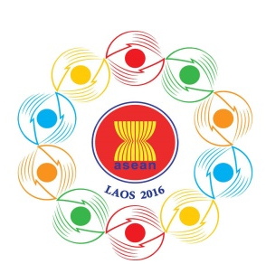
Turning Vision into Reality

for a Dynamic ASEAN Community
Laos 2016
‘Promoting Defence Cooperation for a Dynamic ASEAN Community’

10th ASEAN Defence Ministers’ Meeting (ADMM)

National Convention Center
Vientiane, Lao PDR, 24-27 May 2016

Provisional Agenda

- Opening Remarks by ADMM Chair

- Adoption of Agenda

- Recent Developments in ASEAN by the Secretary-General of ASEAN

- Report of the ASEAN Defence Senior Officials’ Meeting (ADSOM) and ASEAN Defence Senior Officials’ Meeting-Plus (ADSOM-Plus), 22-25 March 2016 by ADSOM / ADSOM-Plus Chair

- Report of the 13th ASEAN Chiefs of Defence Forces’ Informal Meeting (13th ACDFIM), 13-15 March 2016

- Exchange of Views on Regional and International Security and Defence Issues

- Adoption of Papers on:

  - Terms of Reference of ASEAN Militaries Ready Group (AMRG) on Humanitarian Assistance and Disaster Relief (HADR)

  - Terms of Reference of ASEAN Center of Military Medicine (ACMM)

  - Concept Paper on the Establishment of the ADMM-Plus EWG on Cyber Security

- Adoption of Joint Declaration of the 10th ASEAN Defence Ministers on Promoting Defence Cooperation for a Dynamic ASEAN Community

- Other Matters

- Closing Remarks by ADMM Chair

